**ASSIGNMENT No # 02**

|  |
| --- |
| A7D18627**COMSATS UNIVERSITY ISLAMABAD**  **ATTOCK CAMPUS** |

**MOBILE APP DEVELOPMENT**

|  |  |
| --- | --- |
| Student Name | Ayesha Altaf  SP20-BCS-020 |
| Date of Submission | 28-October-2022 |
| Program | BS-(CS) |
| Semester | VI |

**Instructor: Mr. Muhammad Kamran**

* **CODE**

import * as React from 'react';

import { Text, View, StyleSheet , TextInput , TouchableOpacity, Image} from 'react-native';

import Constants from 'expo-constants';

// You can import from local files

import AssetExample from './components/AssetExample';

// or any pure javascript modules available in npm

import { Card } from 'react-native-paper';

export default function App() {

return (

<View style={styles.container}>

<Image source={{uri: "https://www.Octobox.com/react_native/react_native_images.htm"}} />

<Text style={styles.header}>

Wellcome to OCTOBOX </Text>

<TextInput style={styles.textinput} placeholder="Full Name"

underlineColorAndroid={'transparent'} />

<TextInput style={styles.textinput} placeholder="Email"

underlineColorAndroid={'transparent'} />

<TextInput style={styles.textinput} placeholder="Password"

underlineColorAndroid={'transparent'} />

<TextInput style={styles.textinput} placeholder="Confirm Password"

underlineColorAndroid={'transparent'} />

<TouchableOpacity style={styles.button}>

<Text style={styles.btntext}> Sign Up </Text>

</TouchableOpacity>

<Text style={styles.footer}>

Alreadyamember ? Signin! </Text>

<Card>

<AssetExample />

</Card>

</View>

);

}

>>>>>>>>>>Styling>>>>>>>>>>>>>>>>>

const styles = StyleSheet.create({

container: {

flex: 1,

justifyContent: 'center',

paddingTop: Constants.statusBarHeight,

backgroundColor: '#3478db',

padding: 8,

},

textinput: {

alignSelf: 'stretch',

height: 35,

marginBottom: 20,

color: '#fff',

borderBottomColor: '#f8f8f8',

borderBottomWidth: 1,

},

header: {

margin: 20,

fontSize: 20,

color: '#fff',

paddingBottom: 40,

marginBottom:10,

textAlign: 'center',

},

footer: {

margin: 20,

fontSize: 15,

color: '#fff',

paddingBottom: 40,

marginBottom:10,

textAlign: 'center',

},

button: {

alignSelf: 'stretch',

alignItems: 'center',

textShadowColor: '#308db',

padding: 20,

background: '#3448db',

marginTop: 10,

}

});

* **OUTPUT:**

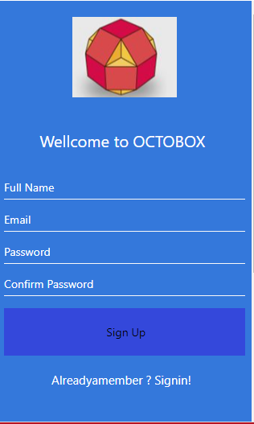

* Sample Screen

